F:\LEOO\D disk\Researches0\Postharvest\学生毕业事项\祝曼\20161119最终数据\第二版\20170628 PCP格式\Supplementary materails\Supplementary Figure S1.tif

Supplementary Figure S1: A representative micrograph of pooled fractions from band 1 to band 4 isolated by a discontinuous sucrose gradient.

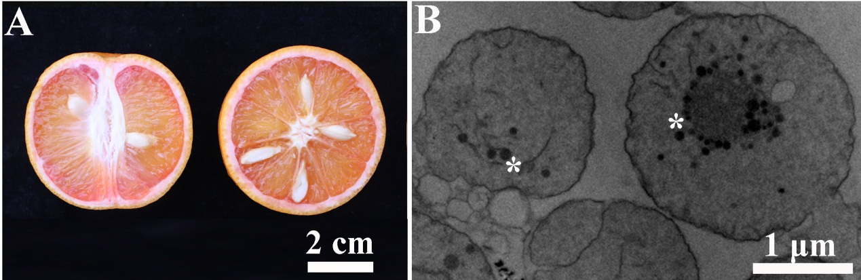

Supplementary Figure S2. Fruits of ‘Hong Anliu’ orange and isolated chromoplasts from its flesh. (A) A representative graph of sweet orange used for chromoplasts isolation. (B) A TEM image showing ultrastructural chromoplasts in the flesh of sweet orange. Asterisks indicate the plastoglobules within chromoplasts.

E:\LEOO\D disk\Researches0\Postharvest\student\zm\2016年\20161119final\第二版\20170813 HR\20171007 HR response\Supplementray materials\Supplementary Figure S3.tif

Supplementary Figure S3: Functional comparison of plastidial proteins identified from elaioplasts and chromoplasts. Proteins were classified into 32 functional categories according to MapMan (verified by PPDB, Thimm et al., 2004; <http://mapman.mpimp-golm.mpg.de/>).

***Reference***

Thimm, O., Blasing, O., Gibon, Y., Nagel, A., Meyer, S., Kruger, P., et al. (2004) MAPMAN: a user-driven tool to display genomics data sets onto diagrams of metabolic pathways and other biological processes. *Plant J.* 37: 914-939.